Sprint 1 - Endurance Design Document

November 16, 2020

Use this Requirements Specification template to document the requirements for your product or service, including priority and approval (Must do).

This document will also serve as a System Design Document (How to) and will include sections detailing system flow, algorithms, staffing plan, software/hardware, and Test Plan

This document contains instructions and examples which are for the benefit of the person writing the document and should be removed before the document is finalized.

To regenerate the TOC, select all (CTL-A) and press F9.

Table of Contents

1. Executive Summary 3

1.1 Project Overview 3

1.2 Purpose and Scope of this Specification 3

2. Product/Service Description 3

2.1 Product Context 3

2.2 User Characteristics 3

2.3 Assumptions 3

2.4 Constraints 3

2.5 Dependencies 4

3. Requirements 4

3.1 Functional Requirements 5

3.2 Security 5

3.2.1 Protection 5

3.2.2 Authorization and Authentication 6

3.3 Portability 6

4. Requirements Confirmation/Stakeholder sign-off 6

5. System Design 6

5.1 Algorithm 6

5.2 System Flow 6

5.3 Software 6

5.4 Hardware 6

5.5 Test Plan 7

5.6 Task List/Gantt Chart 7

5.7 Staffing Plan 7

# Executive Summary

## Project Overview

This product is going to work to move packages around. We are intending to sell this product to a postal service.

## Purpose and Scope of this Specification

The purpose of this project is to show investors how a small robot system can be used in larger machinery to carry packages/mail. These small robots cannot carry packages, but the software used will be in larger machinery. It is to replace people and make mailing more efficient.

In scope

The following items in phase 3 of Project A are in scope:

* The robot would be used for residential and commercial use.
* It must be used for moving objects from point A to point B.
* Intended for efficiently in postal services.

Out of Scope

The following items in phase 3 of Project A are out of scope:

* This robot is not intended to be used as a lethal weapon.
* Robots are not intended for military use.

# Product/Service Description

This product is designed to be traveling a certain path around the warehouse to bring mail and packages from point A to point B. The product was created due to many postal services failing to deliver packages on time during the Covid-19 pandemic. Many packages were lost or delivered in an untimely fashion, which resulted in lost revenue from small and large businesses.

## Product Context

This product relates to other delivery machines in other warehouses. What is different is that engineers can control the pathway where the robot will be used, and it could shift within real time. Once the code is written to the robot. It is independent and will repeat the code until further instructed. There is other machinery that is similar, but our software interface does not require an ample amount of time to change the code if necessary.

## User Characteristics

Profiles should include:

* Postal Services
* Residential Use
* Commerical Use
* University mailrooms
* -general knowledge of block code
* -general knowledge of technology. How to turn the robot on and off.

## Assumptions

* There must be a clear path on the ground, so nothing blocks the robot on its path.
* The path must be smooth so the robot can glide across easier.
* Users should become clear with the instruction manual, how to use it, write block code and how to charge it, etc. \***Residential Use**
* IT departments should familiarize themselves with the code and use it as how they would like the product to perform. **\*Commercial Use**

## Constraints

Describe any items that will constrain the design options, including

* The code will not change unless it is changed manually.
* The robot is not apt to open unauthorized mail.
* The program is only in block code.

## Dependencies

List dependencies that affect the requirements. Examples:

* This will need to be charged daily.
* Users for residential use will need to read an instruction manual
* The ground must be smooth, flat and not obstructed.

# Requirements

Priority Definitions

The following definitions are intended as a guideline to prioritize requirements.

* Priority 1 – The requirement is a “must have” as outlined by policy/law
* Priority 2 – The requirement is needed for improved processing, and the fulfillment of the requirement will create immediate benefits
* Priority 3 – The requirement is a “nice to have” which may include new functionality

It may be helpful to phrase the requirement in terms of its priority, e.g., "The value of the employee status sent to DIS **must be** either A or I" or "It **would be nice** if the application warned the user that the expiration date was 3 business days away". Another approach would be to group requirements by priority category.

## Functional Requirements

The following table is an example format for requirements.

| Req# | Requirement | Comments | Priority | Date Rvwd | SME Reviewed / Approved |
| --- | --- | --- | --- | --- | --- |
| ENDUR_01 | We want robots to turn green and start going straight. | This is how we know the robot is about to start. | 1 | 11/9 | 11/9 |
| ENDUR_02 | Robot says “Ready, Set, Go” | The robot will say this as it is about to move. | 1 | 11/9 | 11/9 |
| ENDUR_02 | We want the robot to turn right and continue straight. | This is the first way the robot must go, it's important for it to be straight. | 1 | 11/9 | 11/9 |
| ENDUR_03 | Once it gets to the second check point, we want it to turn right again. | Making sure the robot is on the right path. | 1 | 11/9 | 11/9 |
| ENDUR_04 | Once it hits the third check point, we want it to make its final right turn. | Same as above. | 1 | 11/9 | 11/9 |
| ENDUR_05 | Continue straight until the robot it at its starting point, because it is its ending point to. | Same as above. | 1 | 11/9 | 11/9 |
| ENDUR_06 | Robot turns red | Tell us when it's finished traveling the course. | 1 | 11/9 | 11/9 |
| ENDUR_07 | Robot speaks, “I’m tired, I need water” | This lets us know the robot is done. | 1 | 11/9 | 11/9 |
| ENDUR_XX | End Program | Program has ended | 2 | 11/9 | 11/9 |

## Security

### Protection

* All users- the robots will only work from the locations speho.edu has approved from.
* It will have a pre-installed list of locations that were authorized.
* GPS tracking.
* Theres a hard protection shell around the robot.
* The robot can only be accessed with the account associated with it.

### Authorization and Authentication

* You must sign into sperho.edu on the app.

## Portability

If portability is a requirement, specify attributes of the system that relate to the ease of porting the system to other host machines and/or operating systems. For example,

* Percentage of components with host-dependent code: 100%
* Percentage of code that is host dependent: 50%.
* Use of proven portable language: Block Code
* Use of a particular operating system: Robot/ Block code.
* The product will work the same for any environment, but the application will differ between each type of use.

# Requirements Confirmation/Stakeholder sign-off

|  |  |  |
| --- | --- | --- |
| Meeting Date | Attendees (name and role) | Comments |
| 11/11/2020 | Mia Lizzo, Ransom Miller, Vincent Negri | Confirmed all. |

# System Design

This section will provide all details concerning the technical design, staffing, coding, and testing the system

## Algorithm

Develop and describe here the algorithm that will be used to provide the required performance of your software

* Step 1: Robot light turns green. Before starting up the robot LED should turn green.
* Step 2: Robot says, “ready set go.” Before starting up the robot should speak, “ready, set, go”
* Step 3: Robot goes straight. The robot will begin going down in the first part of the course.
* Step 4: Robot turns right. The robot will continue to move and turn right into the second part of the course.
* Step 5: Robot goes straight. The robot will then travel to the second part of the course.
* Step 6: Robot turns right. The robot will continue to move and turn right into the third part of the course.
* Step 7: Robot goes straight. The robot will then travel the third part of the course.
* Step 8: Robot turns right. The robot will continue to move and turn right to the last part of the course.
* Step 9: Robot goes straight. The robot will then travel to the last part of the course.
* Step 10: Robot stops. The robot will stop at the point where it started.
* Step 11: Robot light turns red. The robot light will turn red to tell the owner it has stopped.
* Step 12: Robot speaks, “I’m tired and I need water.” The robot will speak the desired phrase to signal the owner that the program has ended.

## System Flow

Develop a flowchart (and show here) that accurately depicts how your software application will act to fulfil the algorithm

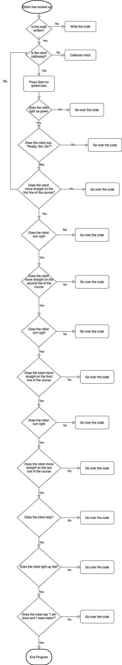

## Software

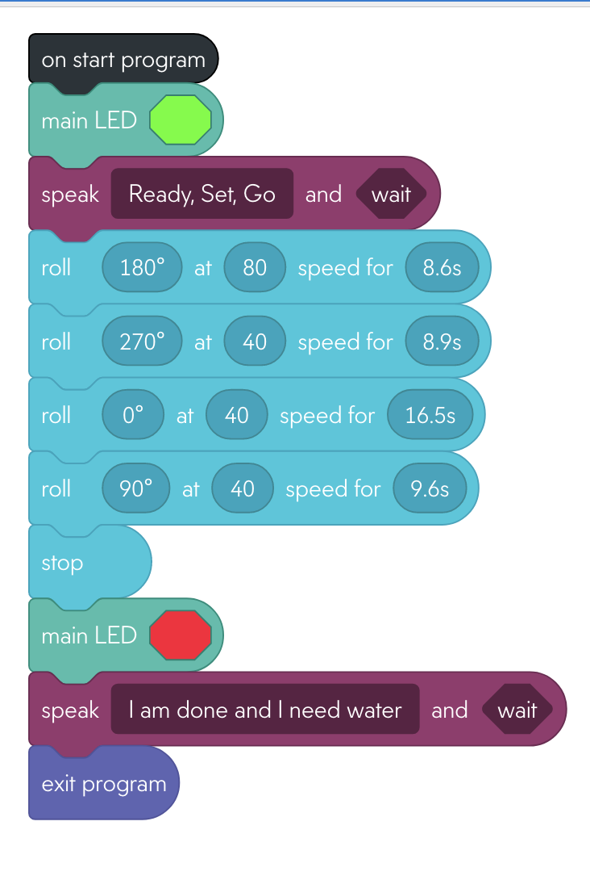

## Hardware

* We used sphero.edu to develop, test and demonstrate this application.

## Test Plan

Include a test plan showing all unit tests performed for this application, including test rational, test date, staff member, pass/fail status

| **Reason for Test Case** | **Test Date** | **Expected Output** | **Observed Output** | **Staff Name** | **Pass/Fail** |
| --- | --- | --- | --- | --- | --- |
| Calibration Test | 11/4 | The robot will follow the first line. | The robot did not follow any line. | Ransom + Vinnie | Fail |
| Calibration Test | 11/4 | The robot will follow the first line. | The robot did not follow any line. It went to the right, not straight. | Ransom + Vinnie | Fail |
| Calibration Test | 11/4 | The robot will follow the first line. | The robot followed the correct line. | Ransom + Vinnie | Pass |
| Will the robot light up green and say “Ready, Set, Go”? | 11/4 | The expectation is that the robot would light up green and say the desired phrase | The robot lit up green and said the desired phrase | Ransom + Vinnie | Pass |
| Will robot make the desired turns? | 11/4 | We expected that it could make sharp turns depending on the angle we told it to turn at | It was able to make sharp turns. | Ransom + Vinnie | Pass |
| Can robots complete the course according to the set parameters? | 11/4 | We expected that we could get the robot to complete the course under the guidelines set. | We could not get the robot to complete the course. | Ransom + Vinnie | Fail |
| Can the robot follow the endurance course as follows | 11/9 | The robot will complete the course near the lines of the course. | The robot went off track and could not complete the course. | Ransom + Vinnie | Fail |
| Can the robot follow the endurance course as follows | 11/9 | The robot will complete the course near the lines of the course. | The robot went off track and could not complete the course. It went too far and crashed into objects. | Ransom + Vinnie | Fail |
| Can the robot follow the endurance course as follows | 11/9 | The robot will complete the course near the lines of the course. | The robot completed the course with no problems and has successfully passed the parameters. | Ransom + Vinnie | Pass |

## Task List/Gantt Chart

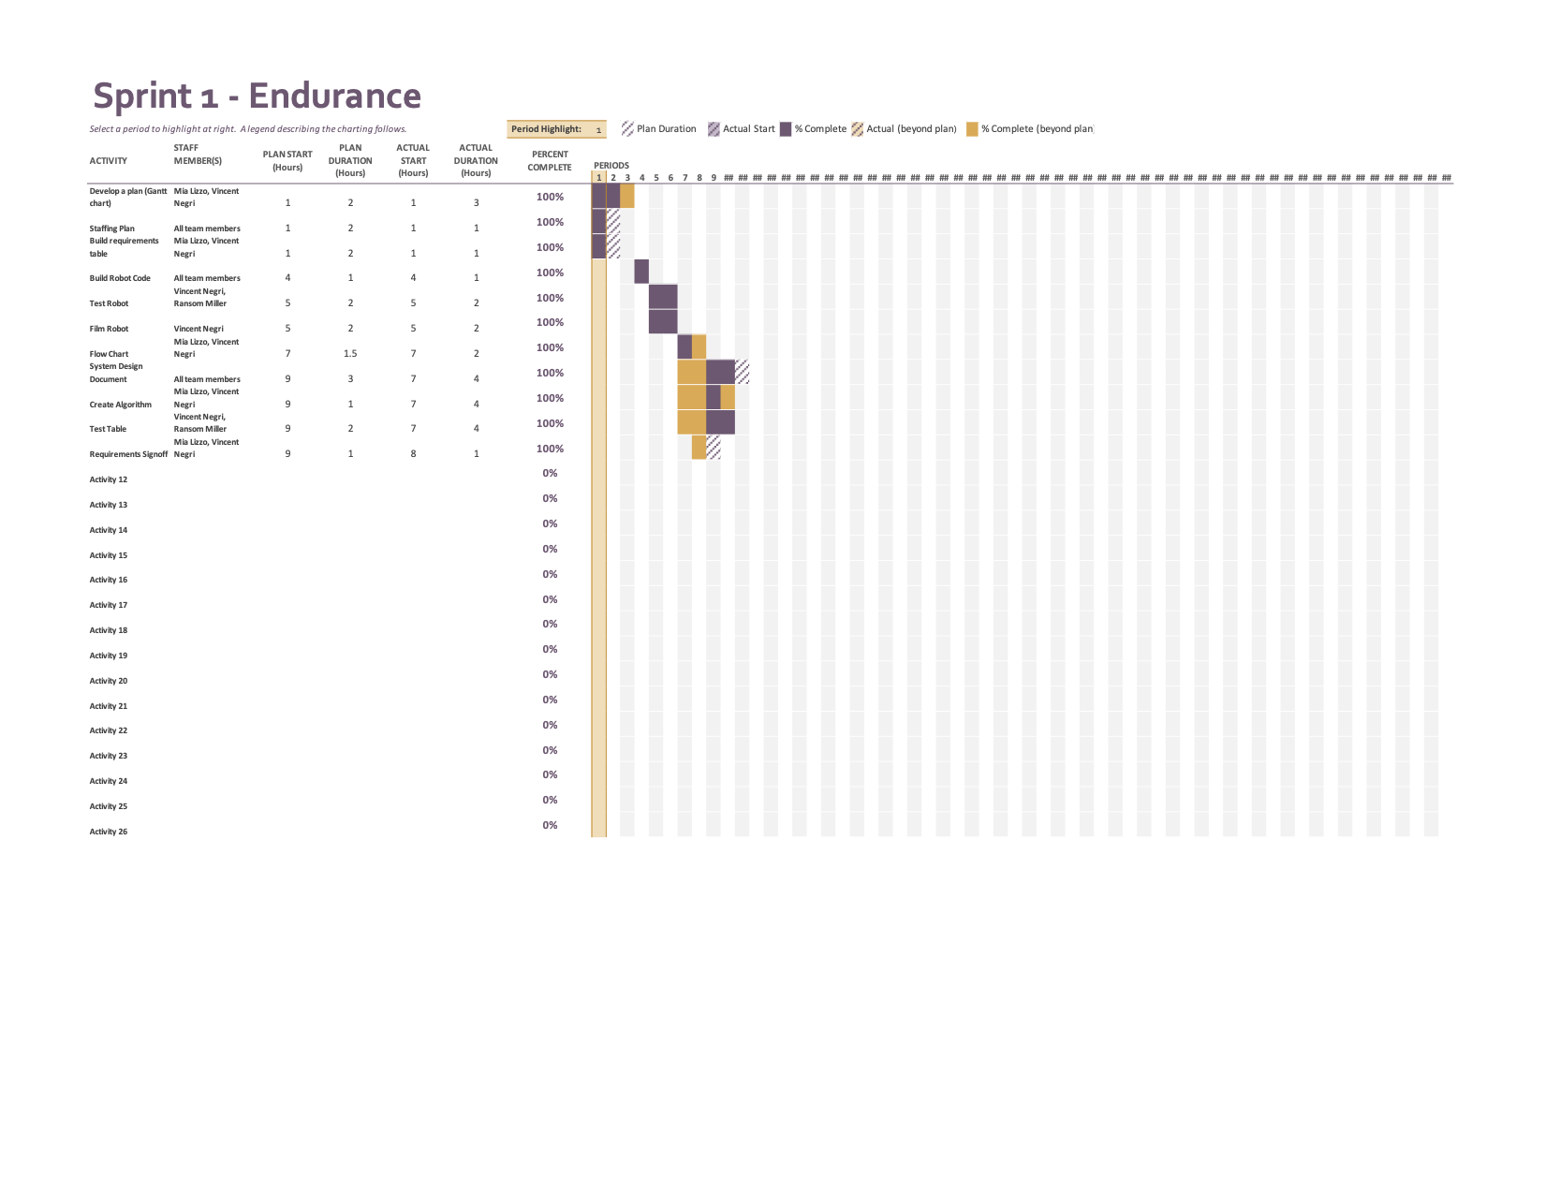

## Staffing Plan

Insert a chart/table that depicts the roles and responsibilities of each team member that worked on this project

| Name | Role | Responsibility | Reports To |
| --- | --- | --- | --- |
| Mia Lizzo | Writer | To document the project and write the necessary definitions. | Vincent Negri |
| Vincent Negri | Leader | To organize, plan and execute this project. Keep the necessary items on track to be completed. Stay on top of team members and himself. | Mia Lizzo & Ransom Miller |
| Ransom Miller, IV | Coder | To keep the robot and write the necessary code within the Sphero program. | Mia Lizzo & Vincent Negri |